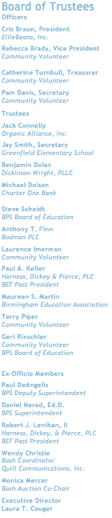
Dear Friends and Supporters,

On Saturday, February 9, 2019, the Birmingham Education Foundation (BEF) will host our annual gala fundraiser, the Unabashed Bash. This wonderful evening at The Townsend Hotel features dinner, dancing, games, and, of course, our auction. Last year, the “Bash” was attended by nearly 300 parents, school leaders and community members, and raised more than $140,000 for Birmingham Public Schools students and classrooms. This year, we’d love your help as we try to raise even more.

We're currently collecting services and items for the auction portion of our event. Our 501(c)3 nonprofit organization is one of the leading education foundations in Michigan and by donating to our auction, you'll be making a tax-deductible contribution that will benefit all 13 BPS schools, while gaining valuable exposure for your business.

If you're unfamiliar with our organization and mission: The BEF is committed to creating exceptional educational experiences by connecting innovative teachers with community support. We do this by granting upwards of $110,000 to BPS teachers annually, and more than $1.2 million to BPS since 2007.

We would like to Thank You for considering this opportunity to partner with our organization. If you have any questions regarding the BEF or the event, please feel free to visit our website (SupportBEF.org) or contact us at bashdonations@gmail.com or 248.203.3030. We would love to tell you more about who we are and what we do.

To contribute, please complete the attached form and submit with your item (when applicable) or contact us for item pickup. (You can also visit SupportBEF.org/unabashed-bash-auction-donation to fill out the donation form online.)
Thank you again for your consideration and best wishes from all of us at the Birmingham Education Foundation.

Sincerely,

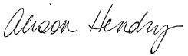
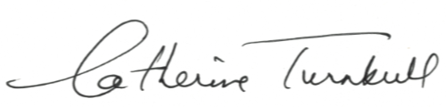

Catherine Turnbull Alison Hendry
Birmingham Education Foundation Executive Director
Auction Chair

P.S. To recognize the generosity and support of our donors, your name and/or business will be prominently featured in our auction materials, as well as on our web site. Thanking you in advance for your support!
Tax ID: 38-3214599

